SIMATS ENGINEERING
ASSESSMENT TOOL 1

COURSE CODE: ITA 0605 COURSE NAME: MACHINE LEARNING

COURSE OUTCOME COVERED

CO1: Learning Problems, Perspectives and Issues, Concept Learning, Version Spaces & Candidate Elimination, Inductive Bias, Decision Tree Learning, Representation & Heuristic Search (BL1, BL2)

Assessment Tool Weightage: 40%

QUESTIONS: 15 Total Marks: 25

Annexure A

APPLICATION BASED QUESTIONS

Code of Conduct:

I yarrabolu Lasya(192524123) (Name / Reg No) certify that this submission is my original work and that I have adhered to the guidelines specified for this assessment.
I understand that any violation of academic integrity rules will result in disciplinary action.

Signature of the student: Y.Lasya

1) In Shop X, there are 20 bottles of pure oil and 30 bottles of adulterated oil,
while in Shop Y, there are 40 bottles of pure oil and 20 bottles of adulterated
oil. A bottle is selected at random from one of the shops, with Shop Y being
twice as likely to be chosen as Shop X. The selected bottle is found to be
adulterated.

Python code: 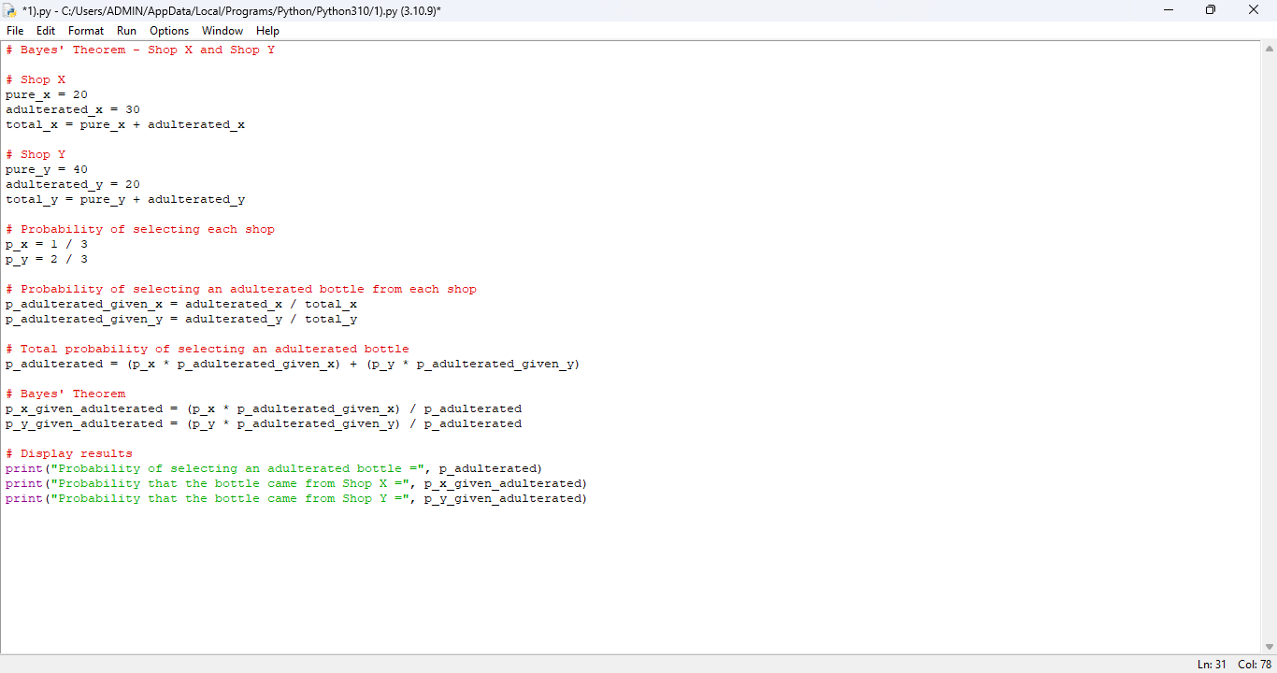

OUTPUT

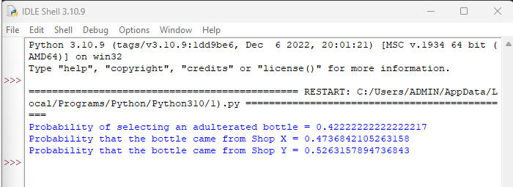

2) A warehouse has two sections. Section A contains 15 defective items and
35 non-defective items, while Section B contains 25 defective items and 25
non-defective items. One section is chosen at random, but Section A is three
times as likely to be chosen as Section B. An item selected from the chosen
section is found to be defective.

Python code :
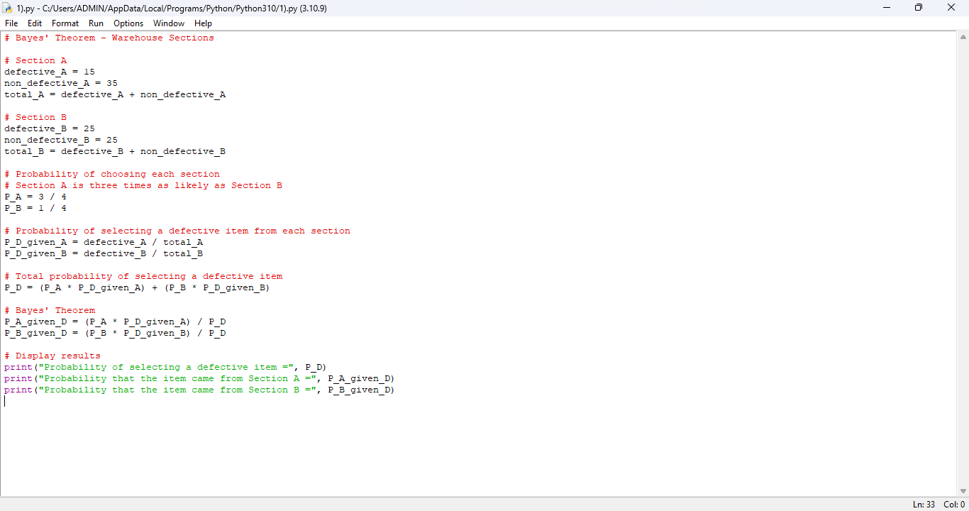

OUTPUT:

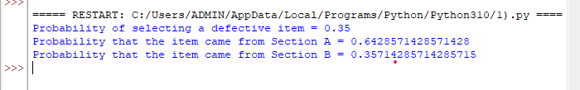

3) In a binary classification problem using a deep learning model with a K-
Nearest Neighbor classifier, the model produces True Positive (TP) = 120 and
True Negative (TN) = 150.The dataset contains 1000 samples per class, and
20% of the data is used for testing.
Find the following: Accuracy, Precision, Sensitivity (Recall), Specificity.

PYTHON CODE:

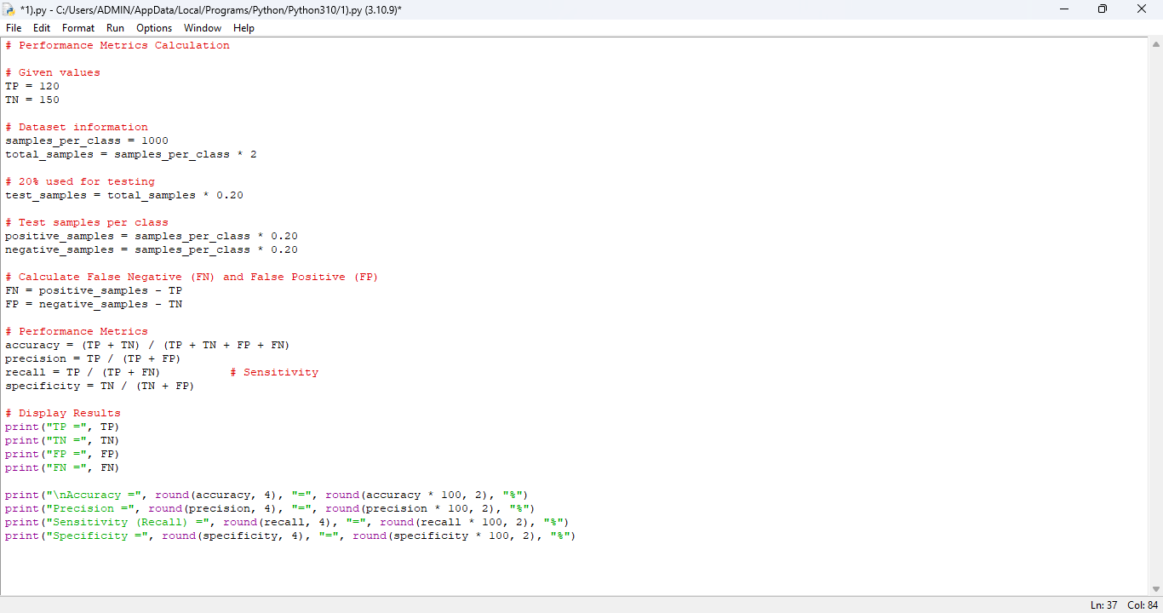

OUTPUT:

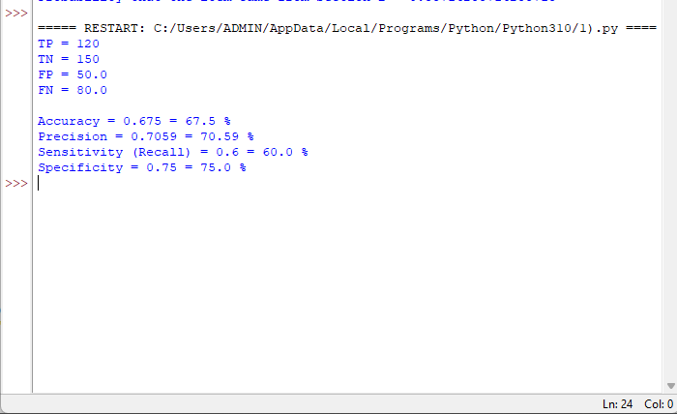
4) A medical image classification system using a deep learning framework
combined with K-Nearest Neighbor (KNN) yields TP = 180 and TN = 160. Each
class contains 1200 samples, and 25% of the dataset is used as test data.
Calculate: Accuracy Precision Sensitivity Specificity.
PYTHON CODE:

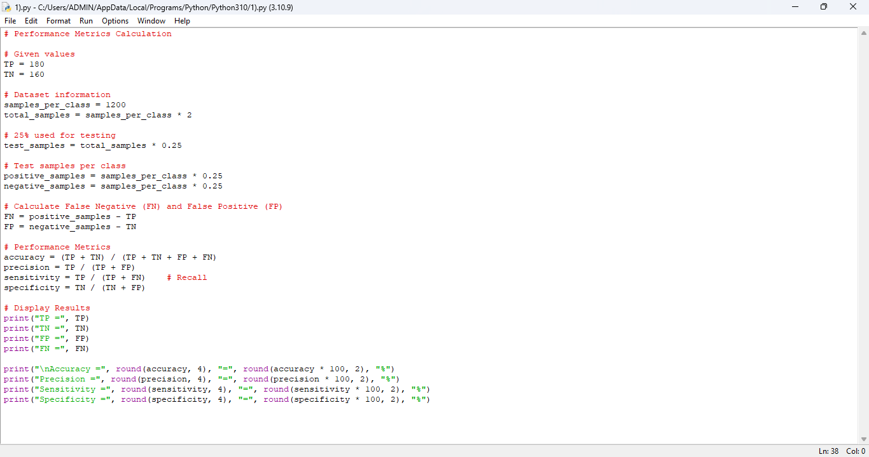

OUTPUT:

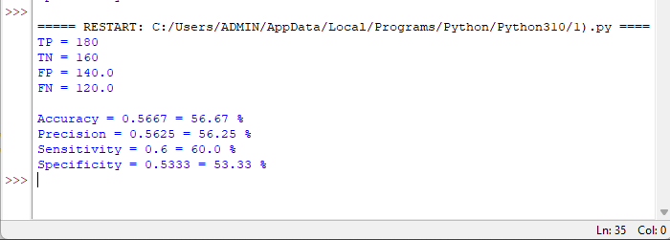
5) A deep learning model is trained for a classification task, and the following
loss values are observed: (5 Marks)
i. Epoch 1: Training Loss = 2.8, Validation Loss = 2.6
ii. Epoch 2: Training Loss = 2.4, Validation Loss = 2.2
iii. Epoch 3: Training Loss = 2.1, Validation Loss = 1.9
iv. Epoch 4: Training Loss = 1.9, Validation Loss = 1.8
v. Epoch 5: Training Loss = 1.7, Validation Loss = 1.9
vi. Epoch 6: Training Loss = 1.5, Validation Loss = 2.1
vii. Epoch 7: Training Loss = 1.3, Validation Loss = 2.4
viii. Epoch 8: Training Loss = 1.2, Validation Loss = 2.7

Answer the following:
a. At which epoch does the model achieve the best generalization
performance?
b. At which point does overfitting begin? Justify your answer.
c. Suggest two techniques to reduce overfitting and briefly explain how
they help.

PYTHON CODE:

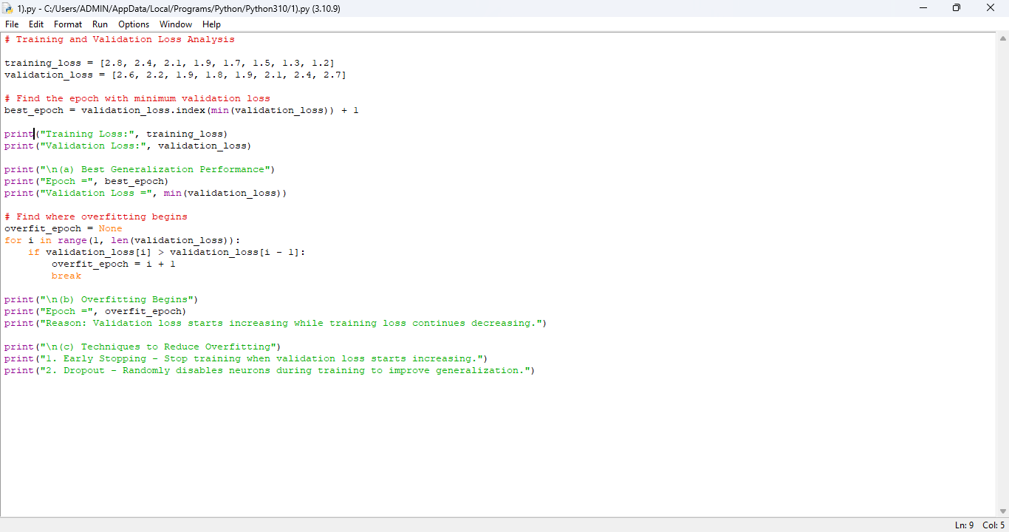

OUTPUT:

